Advertisement Documentation

Contents
The purpose and audience/user requirements 2
Target Audience 3
Audience Requirements 3
Product ideas 3
Styles 3
What would make it appealing for the target audience? 3
Storyboard 4
Timeline 7
Colour schemes and general theme 7
Ideas for soundtracks 7
Test Plan 7
Review 8

The purpose and audience/user requirements
The purpose of this advertisement will be to show computing students what the college will look like for them. It will show them the cafeteria along with the seating areas, the main hall including the pool table and the piano that is on-site, and the classroom, along with descriptions about it, for example, the ad will say about the seating areas being “spacious”, and there being beverages and snacks machines available. Additionally, it will give the students more of an idea of what the college would look like inside as the advertisement will cover the most important facilities, and the advertisement would demonstrate what the classrooms would look like along with descriptions of it, for example for the classrooms the advertisement will talk about what features the classrooms have, so the class being spacious or the windows being large for natural light would make the students more interested, so they would want to know more of what the classroom has to offer, since the advertisement would already have mentioned those features. Another features that would be present in the classrooms are the whiteboards being accessible, large and inclusive for everyone to see, and the fact that there are table workspaces in the classrooms, which will make the students think that they will be doing practical work, like building your very own PCs. Basically, in short, the purpose of this advert is to show the upcoming computing students what the college has to offer.

Target Audience
The target audience is 16-25 year olds that are upcoming Forest of Dean students that are looking for courses which is Computing-related. The target audience would be a big factor for this advertisement as it will need to be visually designed in a way that the target audience would be more familiar to, as if it is designed in a way that the students won’t be familiar to then the students may not be able to pay attention to the advert since it will not be familiar to what they normally see in terms of design. It will also have to be very brief since the advert will be made professionally and the students will not want to read loads of information at once, they would rather want to read information that are very brief and is in separate parts, not all at once. That would make it harder for students to remember everything and therefore it would not be very memorable, hence the information would need to be separate from each other in each part of the advert, like showing off the cafeteria and classrooms.

Audience Requirements
Students would want to know about what the college has to offer inside, like what facilities it provides, like the cafeteria, pool table and classrooms. Students would want the information to be as brief as possible in separate parts. Students would want the advert to be simple-to-understand, minimalistic design so it’s not too much and not over the top really when it comes to transitions and animations. They would also want to hear music that would be appropriate for an academic setting, so a professional genre of music, rather than casual music like rock or pop, since it would sound inappropriate.

Product ideas

Styles
The style of the ad will be basic, simple and professional because of how it will be made, so if we have a look at how the advertisement’s going to go, we can see that there will be transitions and professional royalty-free background music with brief descriptions of what there is in the college in the advert.

What would make it appealing for the target audience?
Bright colours with peaceful music and eye-catching assets like the Gloucestershire College logo (light themed) because it will make students more aware about the advert and it will make them more focused about it, since the ad will showcase to students their facilities like the cafeteria, seating area, vending machines and games like the Pool table.

Storyboard
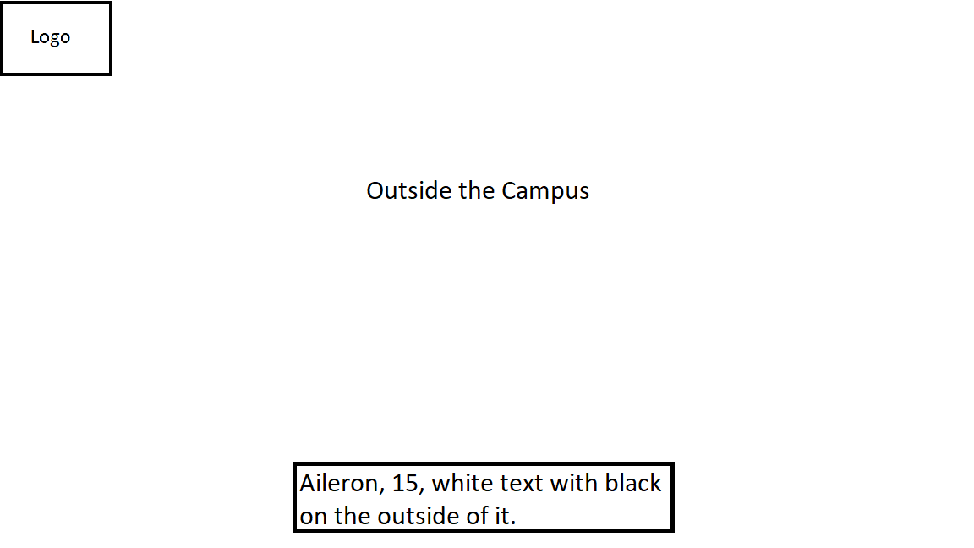
This is the first part of the advert.
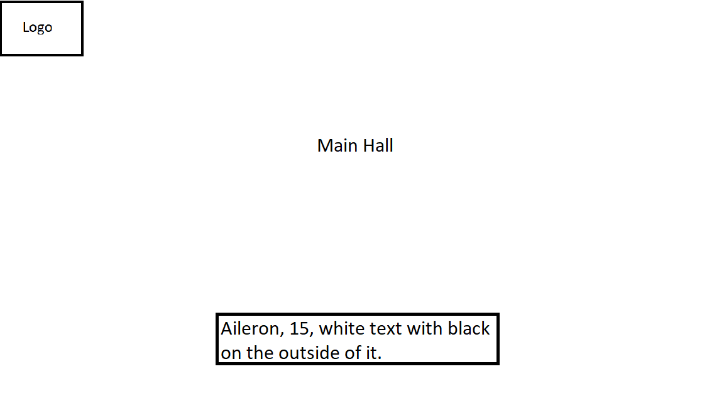
This is the second part of the advert.
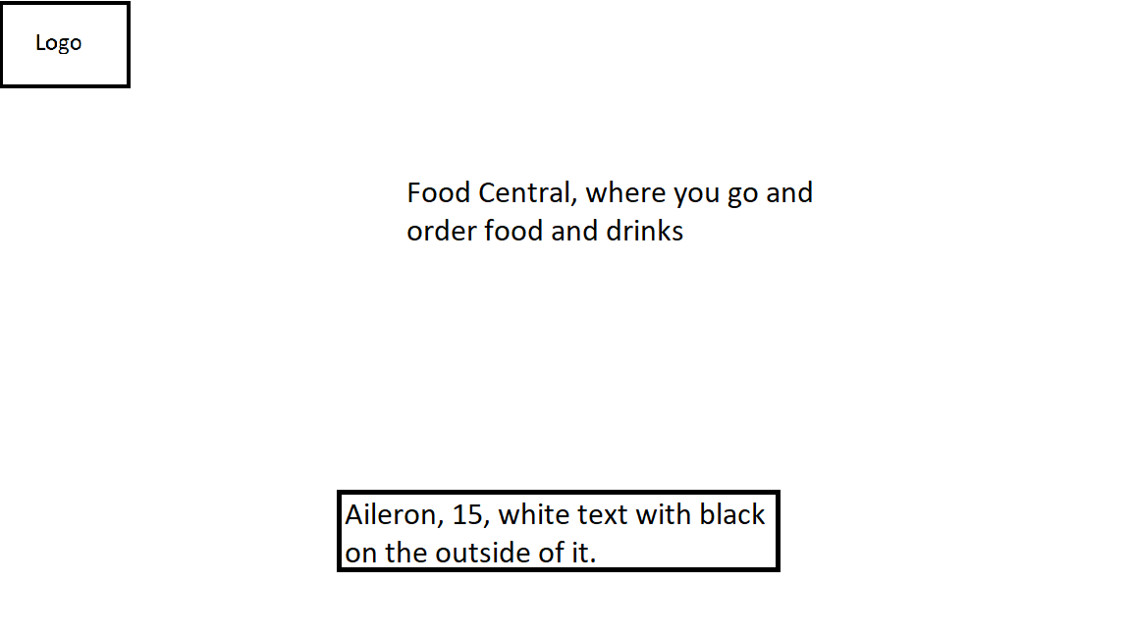
This is the third part of the advert.
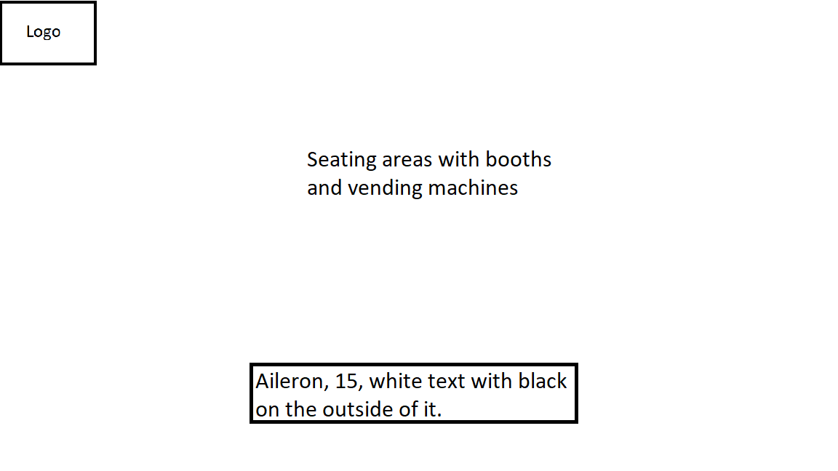
This is the fourth part of the advert.
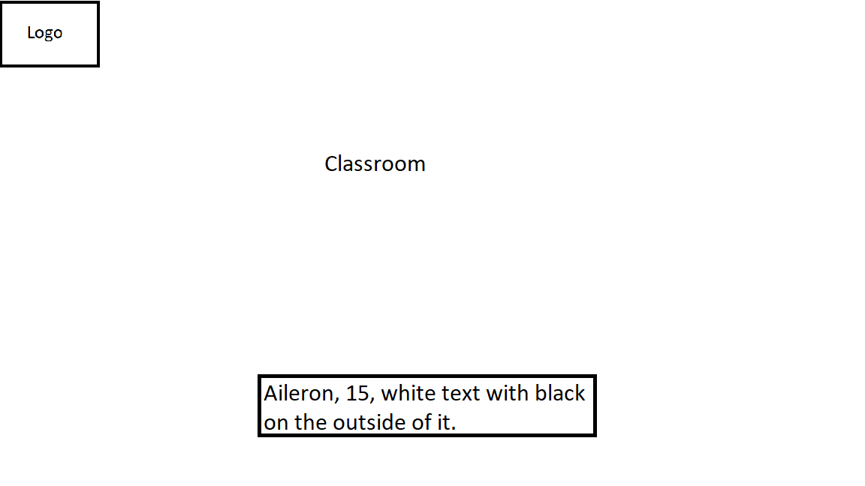
This is the fifth part of the advert.
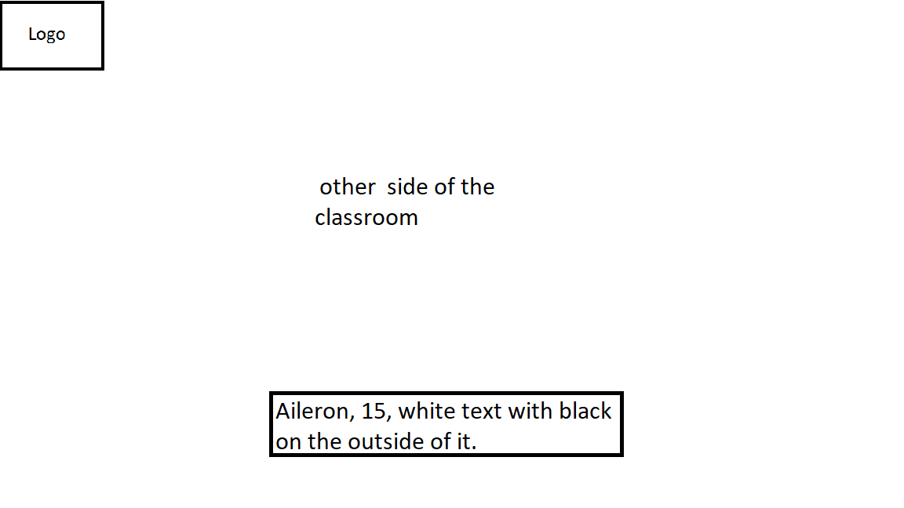
This is the 6th part of the advert.
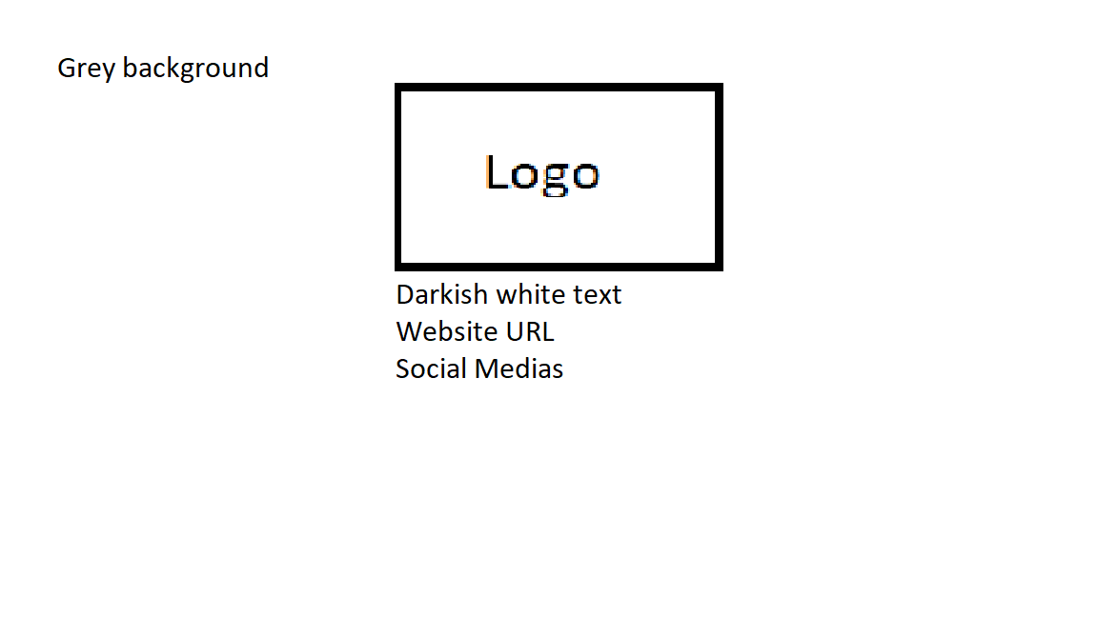
This is the final part (outro) of the advert.

Timeline
- Day 1 – I planned the advert and gotten assets from numerous sources and researched what sort of different fonts, images and the wordings would be best for the advertisement, and seeing if it would match the general theme of it. And after I did that, I then started to work on my storyboard.
- Day 2 – I then started making my advert based on my storyboard.
- Day 3 – I finished the advert, and rendered it in high quality.

Colour schemes and general theme
The colour scheme of this advertisement will be mainly bright colours although despite the end there will be a grey background, almost most of the advert will mainly contain bright colours, and the general theme of this advert will be basic, simple, minimalistic and easy-to-understand because the text, background music and the environment will make it easier for students to remember the campus and what they offer, also the students may want bright colours being put in the advert anyway as it will be eye-catching and it will make the students pay more attention to the advert, because it’s got interesting facilities that will be shown to them like the pool table so students can play pool, the piano so students can play on the piano and the cafeteria – especially separate less-restrictive networks for the students.

Ideas for soundtracks
The idea of the soundtrack will be nice and relaxing for students to listen to while they read and watch the advert. Preferably a more modern and happy music to make it more professional. Students will then be able to remember the advert better and take it more serious because the music will not be aggressive and instead it would be more peaceful to listen to, or in other words the music would be more appropriate.

Test Plan
Test No. | What is it? (Test Description) | What should it do? (Expected Outcome) | Does it work? (Actual Result) | Solution (if No)
1 | Does it render correctly? | The video should render with no visual glitches or any other errors. | Yes, it rendered correctly.
2 | Do the text load correctly? | The text that are present in the video should load with no errors. | Yes, it loaded correctly.
3 | Do the videos that are on the advert load correctly? | The videos that’s in the advert should load with no errors | No, the videos were glitching. | I had to remove the videos and add it back in again on my editor, CapCut.
4 | Do transitions work? | Transitions between each video should work with no errors. | Yes, the transitions loaded correctly.
5 | Does the background music play? | The background music that is on the advert should play. | No, it has not played because it was corrupted. | I had to redownload the background music from the same website in order for it to play again.

Review
At the beginning, I looked at the target audience, which was 16-25, and I considered all aspects that would be useful and topical for this age group, such as in the future they would need to be able to understand the information about the college; the questions students may ask is, what features does the college have? How would you navigate around the college? What does the cafeteria offer? What IT courses do the college offer? That sort of thing. So this advertisement would then answer all of the questions that the students may be thinking of.
I researched and applied different music, text and images that would appeal to the target audience. I experimented different fonts, see which one would be appropriate for the advert. It would make an interesting viewing and it will be informative for future needs.
I included videos of what the college looks like; cafeteria, the main hall, seating areas, and the classrooms. I also included text and a logo of Gloucestershire College at the top left corner. I also included an outro which includes the website for extra information and their social media.

