Interactive PowerPoint Documentation

Contents
Description of the purpose and audience requirements 3
Purpose 3
Target Audience 3
Audience Requirements 3
Product ideas/prototypes 3
Storyboard 4
First Slide 4
Second Slide 4
Third Slide 4
Fourth Slide 5
Fifth Slide 5
Sixth Slide 6
Seventh Slide 6
Eighth Slide 7
Ninth Slide 7
Asset table 8
Timeline 13
Colour schemes and general theme 14
Idea for audio, soundtrack and/or sound effects 14
Test Plan 14
Review 15

Description of the purpose and audience requirements

Purpose
The purpose of the powerpoint presentation will be to demonstrate what the college would be offering to for upcoming Computing students that are looking for which courses to pick in the IT department. The courses that will be on the presentation are Computing, Cybersecurity and Games Design. The powerpoint presentation will also be interactive which means it would be non-linear because students can select which courses they can pick in their own way. Students will then be able to recognise and identify what the course is based on the information that will be on the slides, so if they’d like to find out about Games Design or Computing for instance, because they are interested in that course, then they would read the information that will be on the presentation, and then they’ll be able to flick through slides by clicking on the arrow icons that would take them to either the next slide or the previous slide (which in short they are known as action buttons). This concept and purpose is ideal because there are students out there who would like to learn how to use a computer for the first time, or alternatively they’re interested in learning cybersecurity or learn how to make a video game – who would like to learn what it is all about from a student’s point of view.

Target Audience
The target audience is 16-25 year old upcoming Forest of Dean students that are looking for courses which is Computing related. The target audience would be a big factor for this powerpoint presentation as it will have to be written in a way that the target audience can understand information, so not university-level essays of it, just in a minimalistic, simplistic and a brief way of how the information will be written. Because of the target audience they’d also want colours that isn’t too bright but not too dark as well, so for instance Purple, Dark Aqua and different combinations of dark and bright colours, rather than just pure colours, since the aesthetics may be important for the target audience as well as the aesthetics heavily affects their concentration and it may not be inclusive for everyone in the target audience to see, since it would be either too bright for one of the users in the target audience or too dark for one of the users in the target audience. Hence, the different combinations of colours are in place, and speaking of colours, the colours will match the themes of each courses so students will be more familiar with what the courses are, so for instance, the Cybersecurity course will be in Cyan colours, the Computing will be in Purple colours, and the Games design course will be in dark blue colours.

Audience Requirements
Students would want to read information about Computing-related courses that Gloucestershire College has to offer. Students would also want to see pictures of what the courses look like, and what sort of work they’ll be doing. Pictures, images and content is what would keep students busy, as there will be copyright-free music in place, images from the college’s website, what the courses will offer in terms of what sort of work and topics they would be doing so they’d also expect from the presentation to contain information about what the courses would actually offer.

Product ideas/prototypes

Storyboard

First Slide
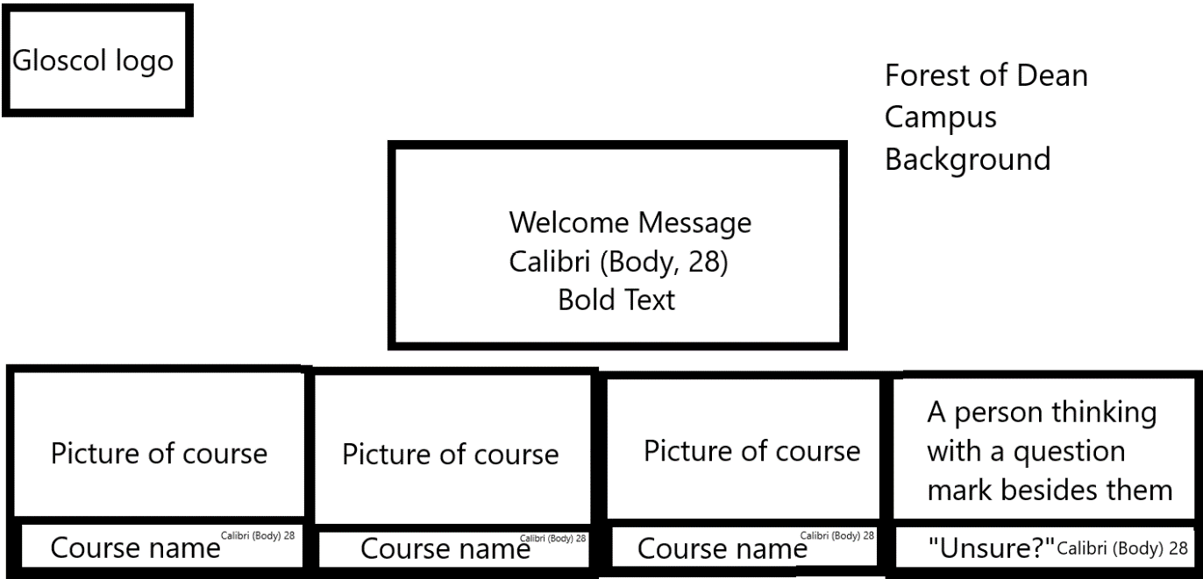

Second Slide
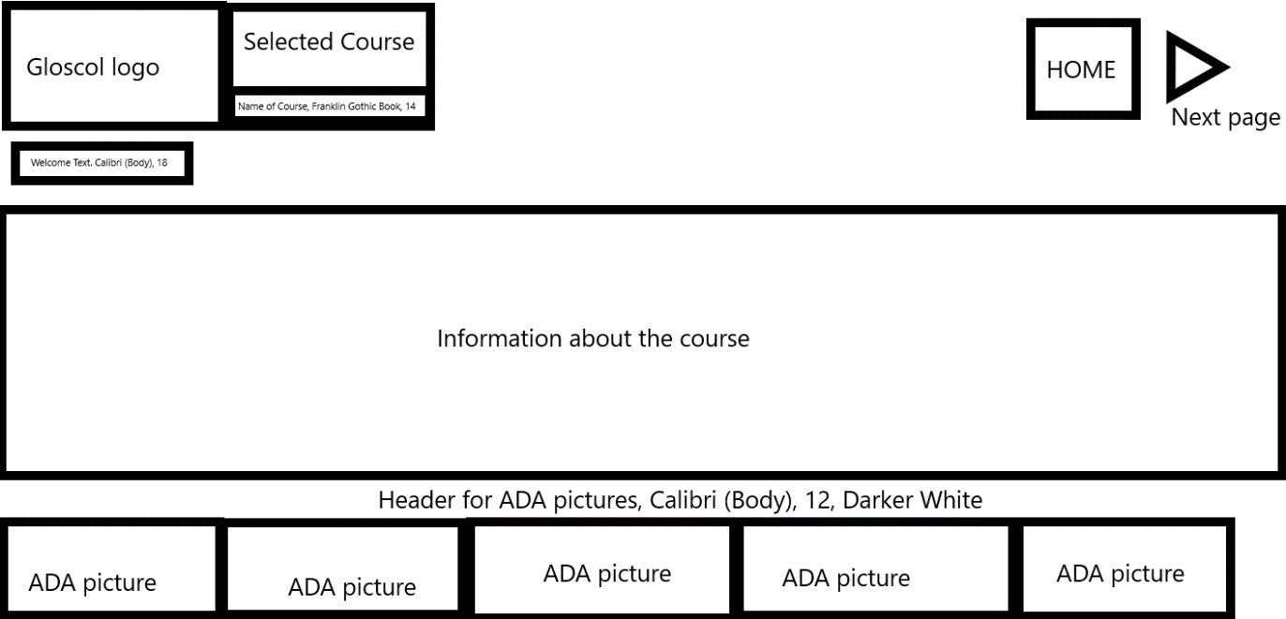
The Welcome text is also in bold and underlined. The header for AQA pictures is in bold too. The background colour for slides 2-7 is a gradient of accented blue and 2 shades of purple.Between slides 2-9 the selected course has the course picture in the box.

Third Slide
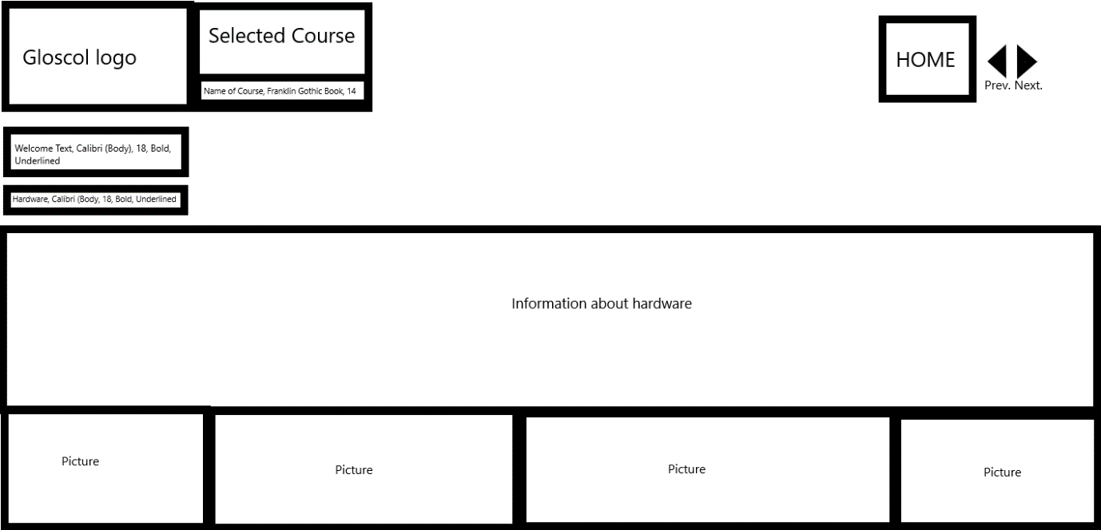

Fourth Slide
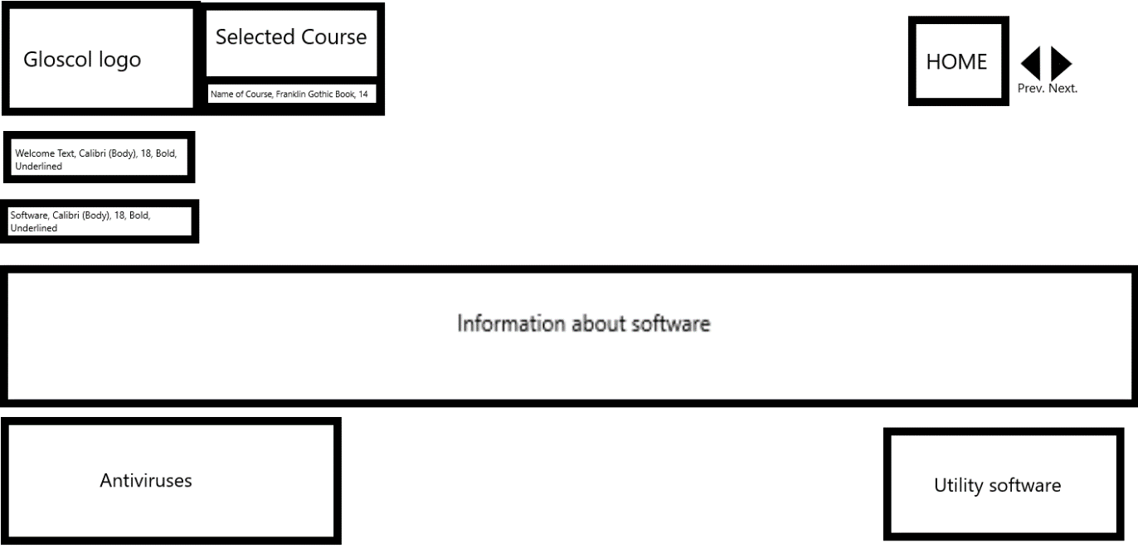

Fifth Slide
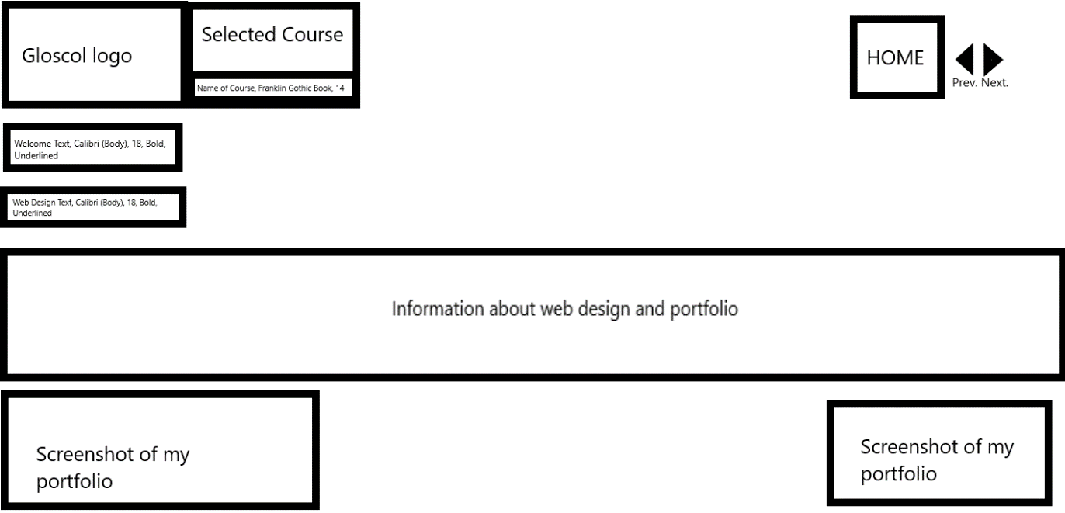

Sixth Slide
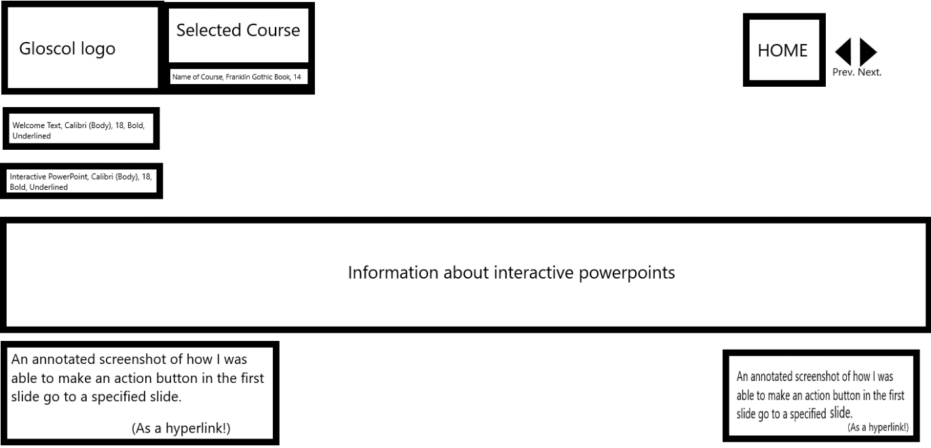

Seventh Slide
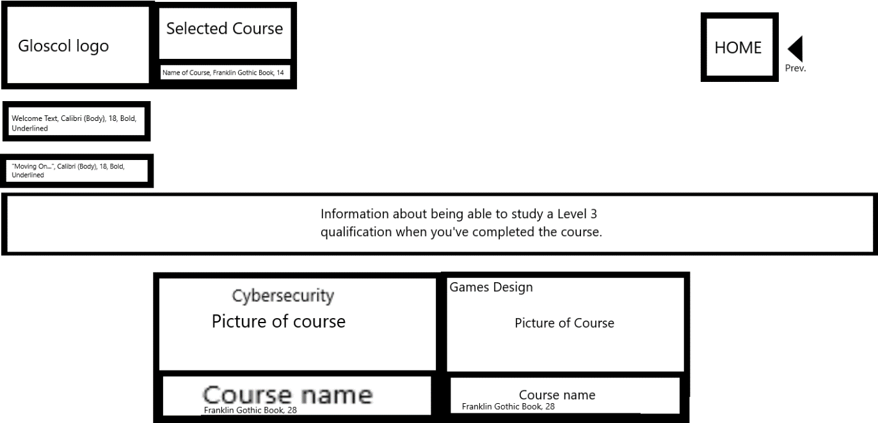

Eighth Slide
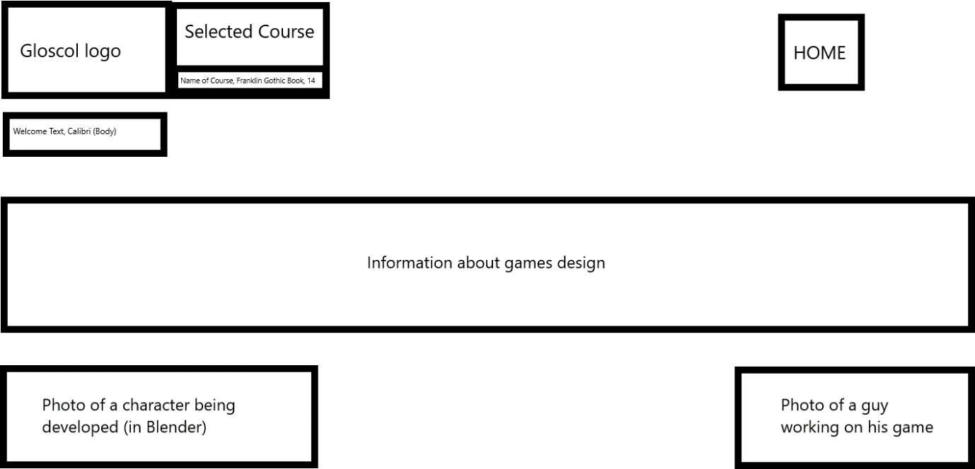

Ninth Slide
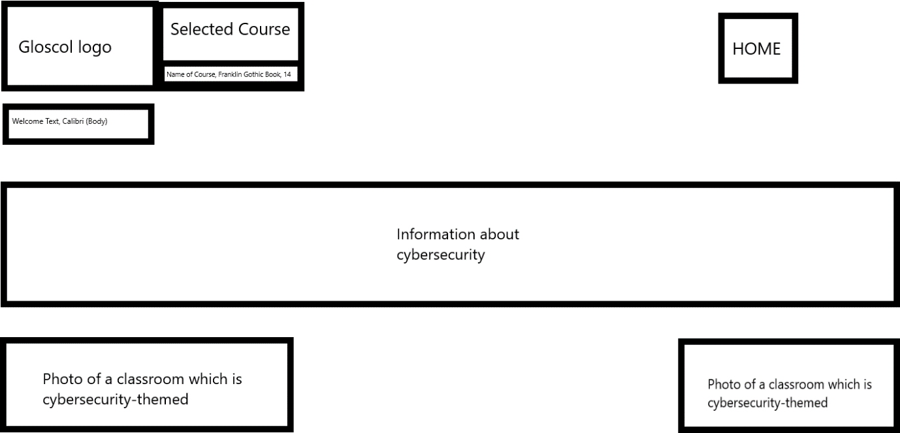

Asset table

Asset | Source | Brief Description
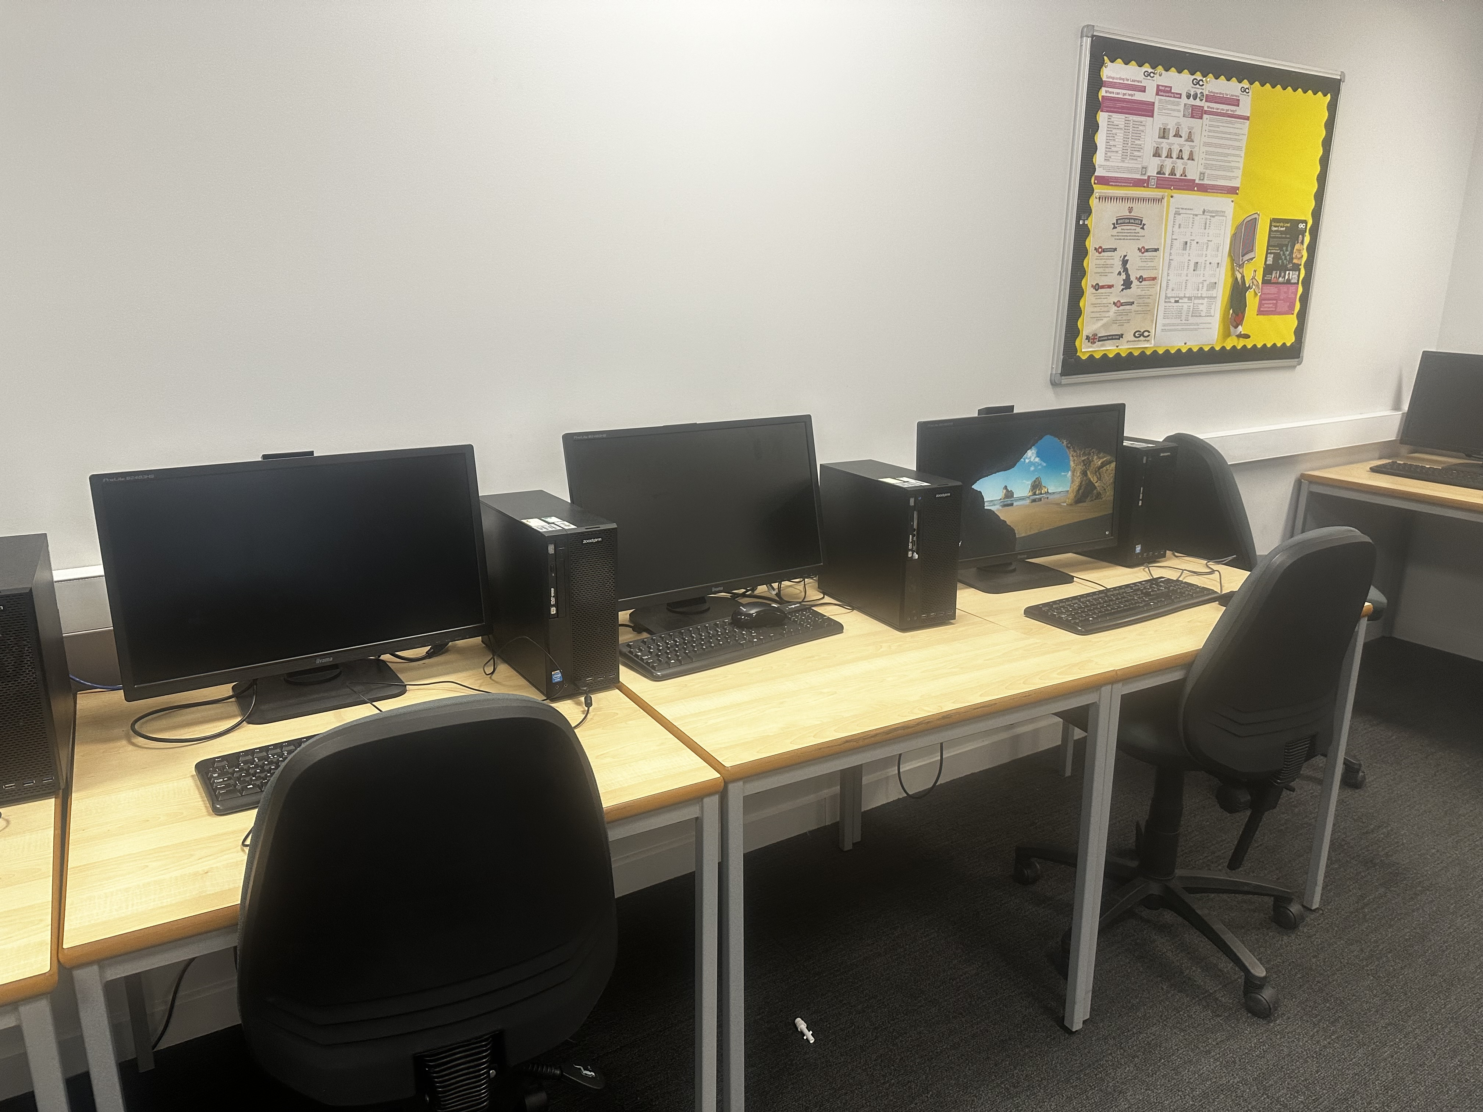 | My picture (used in slide 1-7) | This is my picture of the computers in my classroom. This is used to show students what it is like in a classroom.
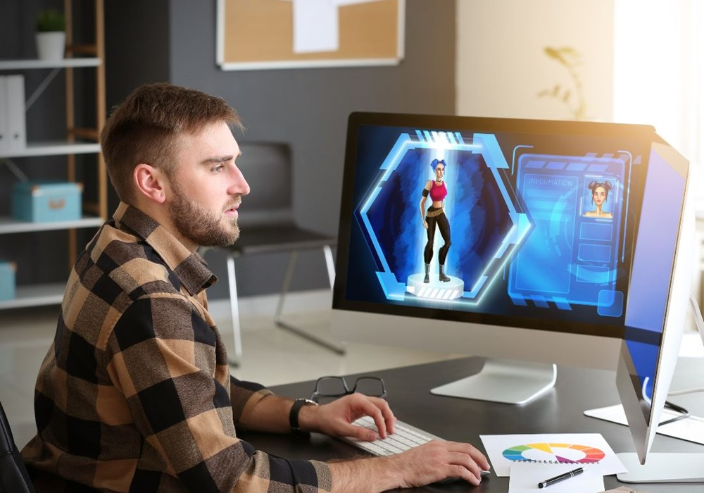 | https://www.gloscol.ac.uk/campaigns/digital-awareness-campaign-games-design/ (slides 1, 7-8) | The man is on a computer developing a video game. This is used in both the college website and my powerpoint. It is used to advertise their course and it is to show students the concept of designing a game.
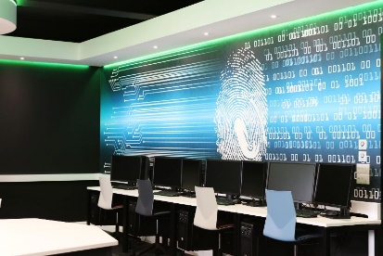 | https://www.gloscol.ac.uk/news-and-events/news/2019/11/a-look-inside-gloucestershire-colleges-brand-new-high-tech-it-training-facilities/ (slides 1, 7, 9) | This is a picture of one of the classroom facilities in Gloucestershire College. This is used to show students how it is like to study cybersecurity
 | https://debajmecrm.com/where-does-dynamics-365-portals-powerapps-portals-store-theme-information-when-you-change-portal-theme-using-powerapps-portal-editor/ (slides 1) | This is a person thinking what to do. This is used in the powerpoint where students can hit the "Unsure?” button so it could have asked students questions and it’d read those questions and then it’d convert it into one of these answers, “Cybersecurity”, “Computing” or “Games Design”.
 | https://www.gloscol.ac.uk (slides 1) | This is the dark themed logo for Gloucestershire College.
 | https://www.gloscol.ac.uk (slides 2-9) | This is the light themed logo for Gloucestershire College.
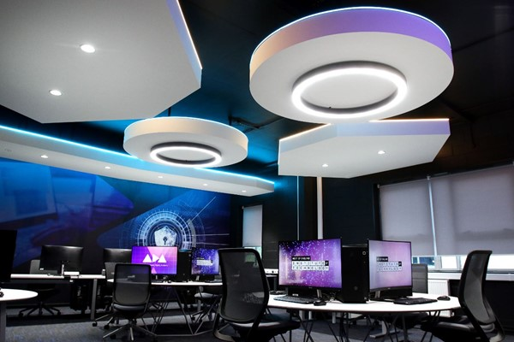 | https://twitter.com/CheltEduPart/status/1441069213712470027 (slides 2) | This is a picture of the ADA Digital Academy facility at Gloucestershire College in Cheltenham Campus.
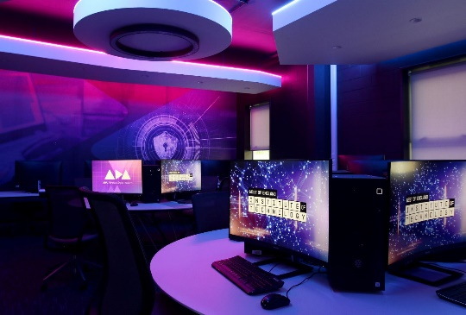 | https://www.gloscol.ac.uk/news-and-events/news/2021/07/gloucestershire-college-unveils-new-cheltenham-facilities-as-part-of-the-west-of-england-institute-of-technology/ (slides 2) | This is a picture of the ADA Digital Academy facility at Gloucestershire College in Cheltenham Campus.
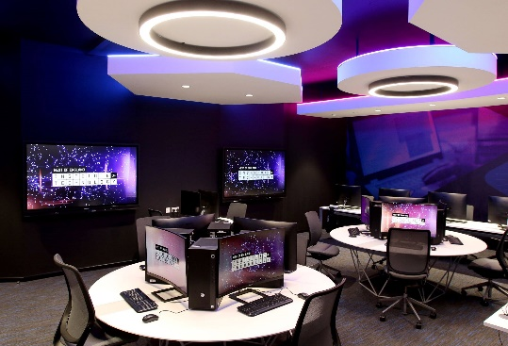 | https://www.gloscol.ac.uk/campaigns/weiot/ (slides 2) | This is a picture of the ADA Digital Academy facility at Gloucestershire College in Cheltenham Campus.
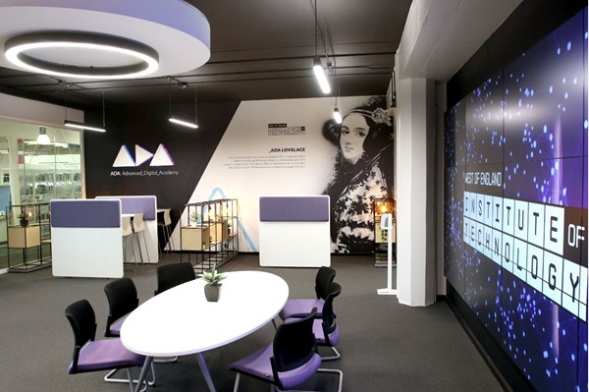 | https://www.gloscol.ac.uk/campaigns/weiot/ (slides 2) | This is a picture of the ADA Digital Academy facility at Gloucestershire College in Cheltenham Campus.
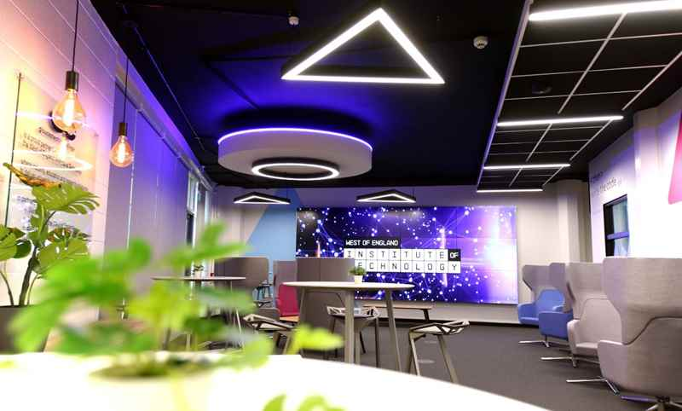 | https://www.gloscol.ac.uk/campaigns/weiot/ (slides 2) | This is a picture of the ADA Digital Academy facility at Gloucestershire College in Cheltenham Campus.
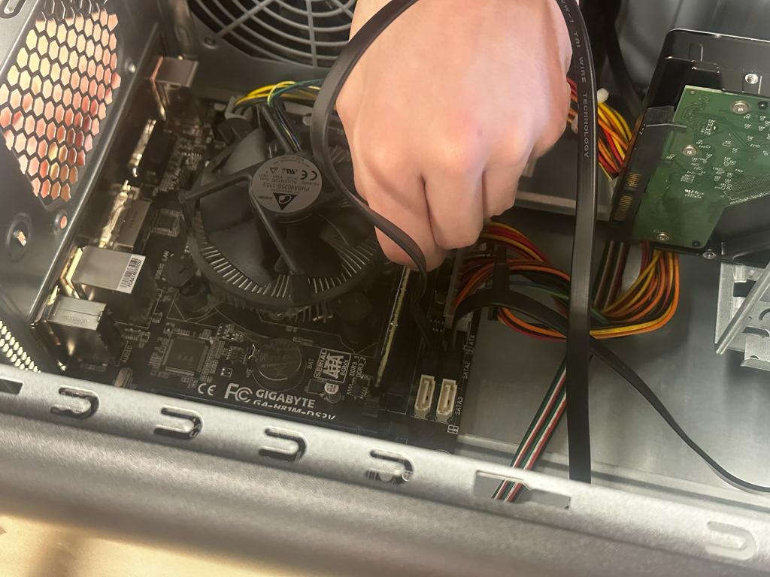 | My Picture (slides 3) | This is my picture used in the Hardware section of the Computing course, to demonstrate to students what they’ll be doing. This picture contains one of my classmates fixing a computer.
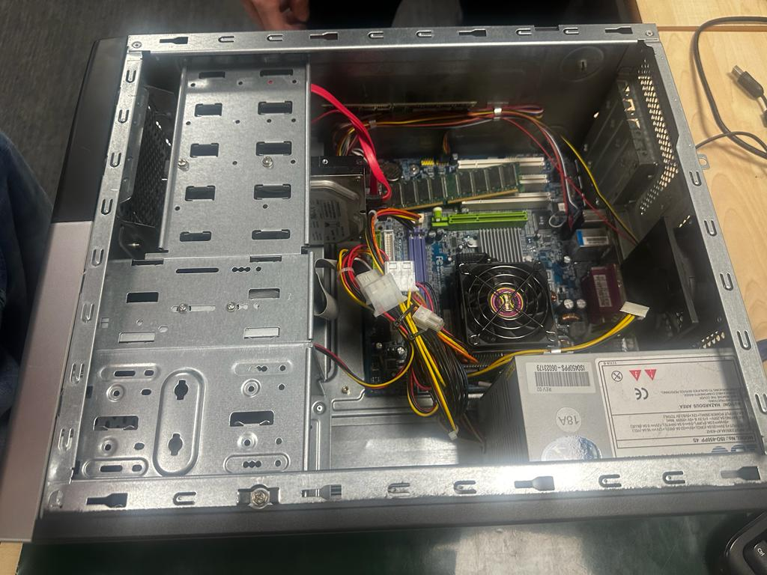 | My Picture (slides 3) | This is my picture used in the Hardware section of the Computing course, to demonstrate to students what they’ll be doing. This picture contains inside of the computer which needs fixing.
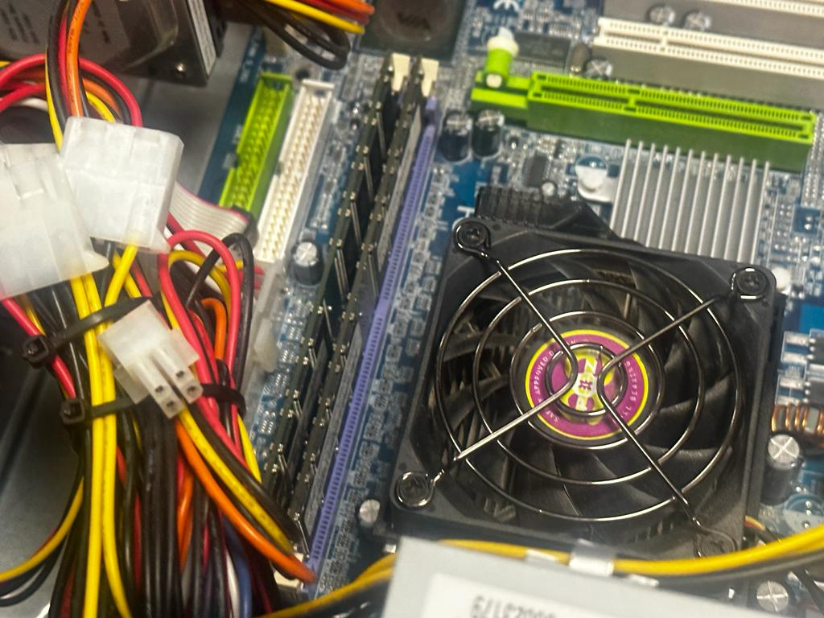 | My Picture (slides 3) | This is my picture used in the Hardware section of the Computing course, to demonstrate to students what they’ll be doing. This picture is a closeup of the CPU and RAM.
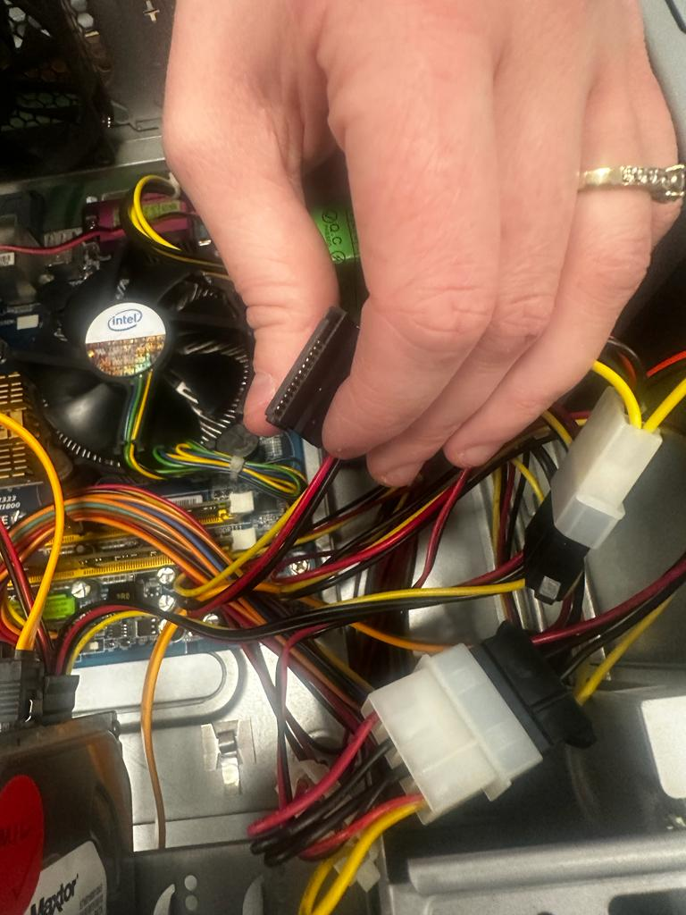 | My Picture (slides 3) | This is my picture used in the Hardware section of the Computing course, to demonstrate to students what they’ll be doing. This picture contains one of my classmates fixing a computer.
 | https://medium.com/@alicewhite07/which-software-offers-the-best-virus-protection-in-2018-2d3cbb491d9a (slides 4) | This is a picture which consists of numerous antiviruses. This is used on the Software section of the Computing course. This is used to show students what antiviruses are.
 | https://irisxzy.wordpress.com/2017/11/29/application-software/ (slides 4) | This is a picture which consists of numerous utility software. This is used on the software section of the computing course. This is used to show students what the utility software are.
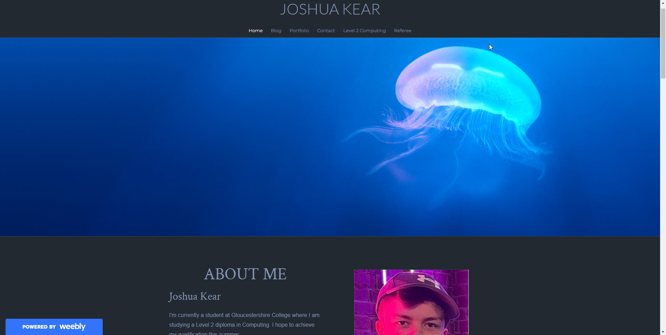 | My Picture (slides 5) | This is a screenshot of my portfolio used on the Web Design section of the computing course. It is the homepage which consists of a lot of information about myself.
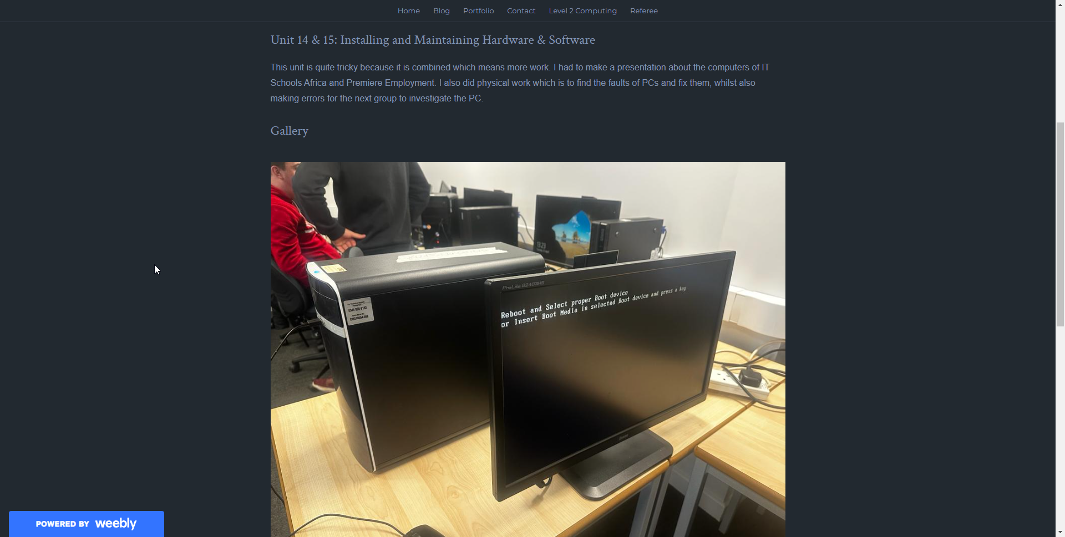 | My Picture (slides 5) | This is a screenshot of my portfolio used on the web design section of the computing course. It is the Unit 14 & 15 webpage which consists of the gallery which contains a lot of images relating to fixing PCs, and remaking issues for another person to fix the PC.
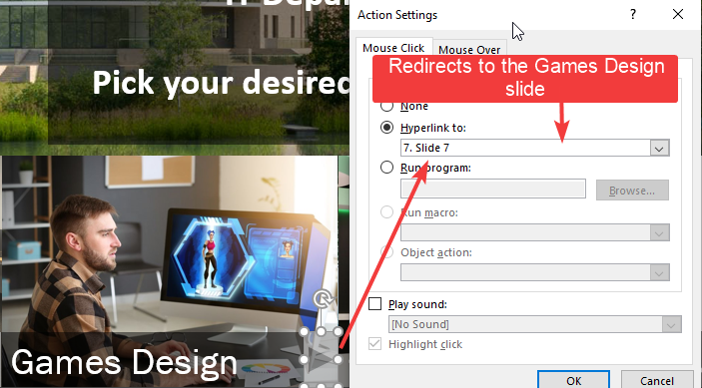 | My Picture (slides 6) | This is my annotated screenshot of how I was able to get a action button to go to the specified slide.
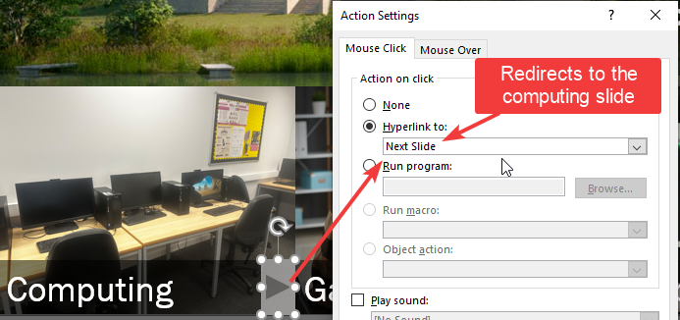 | My Picture (slides 6) | This is my annotated screenshot of how I was able to get a action button to go to the next slide.
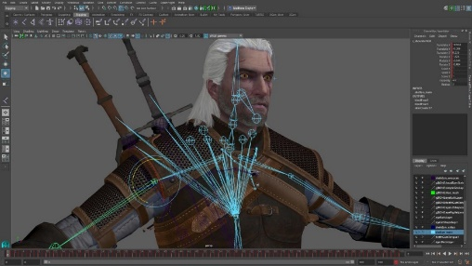 | https://blog.internshala.com/2018/03/game-development-101-exploring-a-career-in-the-gaming-industry/ (slides 8) | This is a screenshot of a character being developed in Blender.
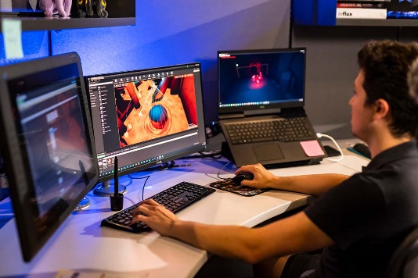 | https://www.ucf.edu/news/ucf-threepeats-as-worlds-best-graduate-game-design-program/ (slides 8) | This is a man working on his video game.
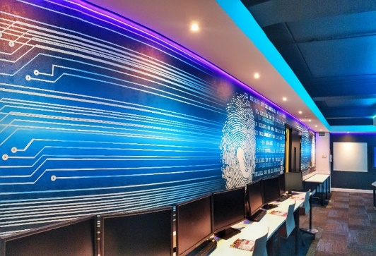 | https://www.gloscol.ac.uk/news-and-events/news/2020/06/gloucestershire-college-announces-new-academic-sponsorship-of-pioneering-cyber-group-cynam/ (slides 9) | This is a picture of one of the classroom facilities in Gloucestershire College at Gloucester Campus. This is used to show students how it is like to study cybersecurity.
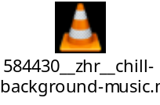 | https://freesound.org/people/ZHRØ/sounds/584430/ (background music) | This is the background music for my PowerPoint presentation.
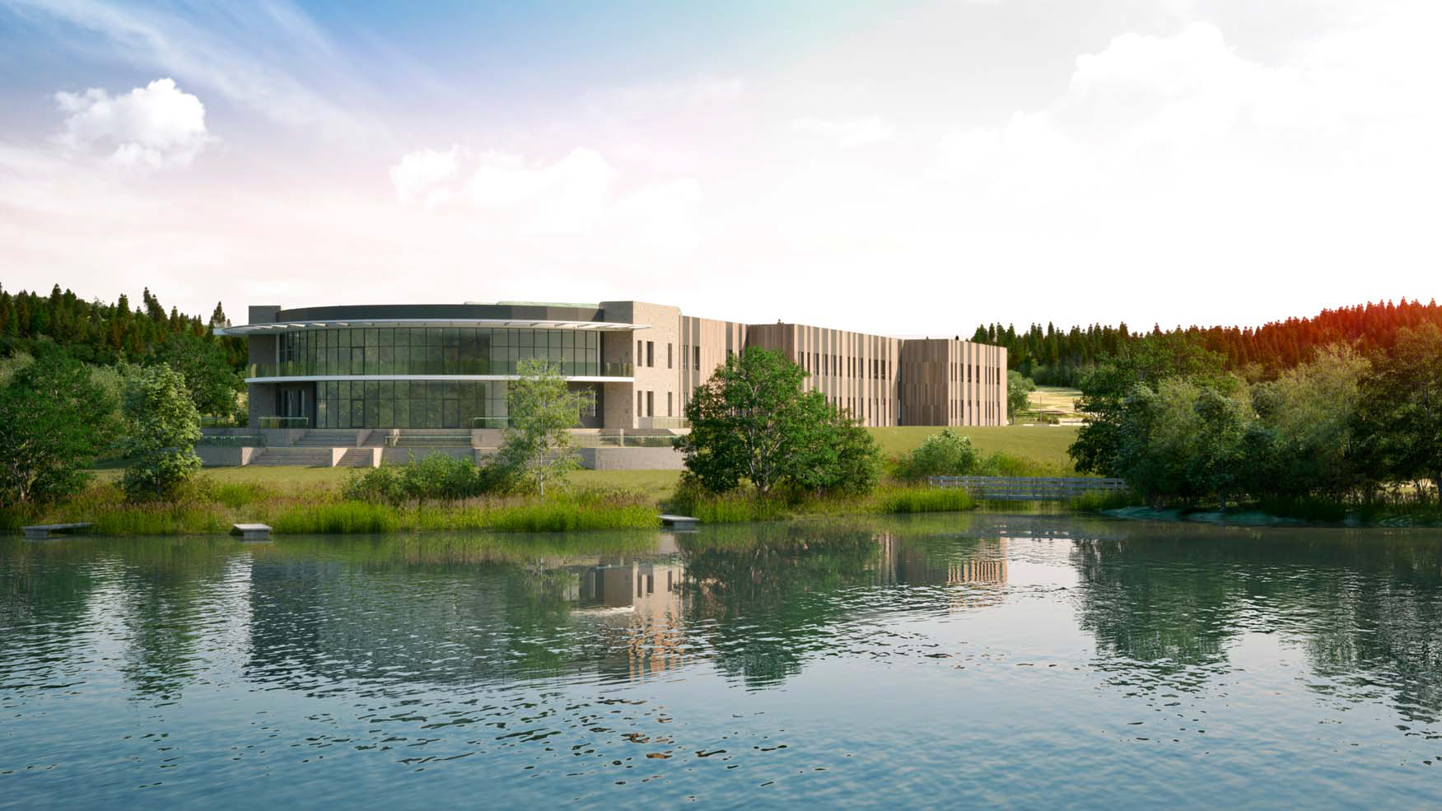 | https://www.gloscol.ac.uk/media/923791/cinderford-draft-view-1.jpg (slides 1) | This is a picture of Cinderford Campus which is used as the background for my first slide.
The last image’s page URL was missing the exact image so I was only able to find the image URL.

Timeline
- Day 1 – I made the presentation and gotten assets from numerous sources like Gloucestershire College because I would use their site to get their logo so I could make it as the logo for my presentation and I have also done research on what would be the best background music for my presentation, like for example it took me a little while to get the background music that I got now because I had to look through and find background songs I liked, which made me test them into my slides and navigating the presentation as a student that would be enrolling into the course, and there are songs that I didn’t like to use so after a little while I finally found the background music I wanted, which personally I feel that is chill music. I feel that would give the students more of a vibe that they can chill to whilst they look at information that is present on the presentation.
- Day 2 – I did a documentation on presentations and I explained what was on my presentation, for example, I explained what the target audience would be for the presentation, and that would be for students, then I explained the colour schemes and basically I did a asset table focusing on my presentation. Then I did a storyboard which is about my slides.

Colour schemes and general theme
The colour schemes in the presentation will vary. For the first slide it will consists of dark colours whilst assets like pictures will be in place. For the background colour scheme of the first slide there will be colours like blue, green, brown and white. For the computing slides the colour schemes will be different from everywhere else like Cybersecurity and Games Design, and for them 2 they will also be different from each other. The Computing slide’s background colour’s colour scheme will be a gradient of accented blue and 2 shades of purple while the angle will be 50 degrees and the type being linear. The text will be white and the navigation buttons will have a gradient of accented lighter white and 3 shades of accented lighter blue.

For the game design slide the background colour will have a gradient of 3 shades of dark blue, whilst there’ll be 2 accents of dark blue which will be at the beginning of gradient stops bar and at the end of gradient stops. The home button will have a gradient of accented lighter white and 3 shades of accented lighter blue.

For the cybersecurity slide the background colour will have a gradient of 2 blue-gray colours which would be at the start and at the end of the gradient stops bar, and 3 shades of turquoise in the middle of the gradient stops.

Idea for audio, soundtrack and/or sound effects
I will be adding from freesound.org background music which is “chill”. I will add this because it is a relatively peaceful music to listen to when you’re trying to read information from the slides. It is also copyright-free and it is part of Creative Commons which means anyone can use it with credit.

Test Plan
Test No. | What is it? (Test Description) | What should it do? (Expected Outcome) | Does it work? (Actual Result) | Solution (if No)
1 | Do the action buttons work? | The action buttons (previous button, home button and next button) should work without any errors. | No, it did nothing. | I’ve had to create and edit hyperlinks for the action buttons in each slide.
2 | Does the background music play? | The music should play in the background. | No, the music hasn’t played. | I’ve had to make it play in the background by clicking onto the music file, and in the Audio Tools section I pressed on the “Playback” button, then in the Audio Styles section in the toolbar I clicked on “Play in Background”, that way it now automatically plays in the background.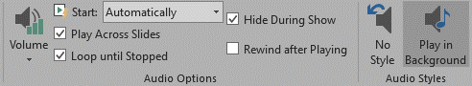
3 | Do transitions work? | The transitions should play when switching to next/previous slides. | Yes, it has played.
4 | Do images load? | The images should load when the presentation’s played. | Yes, the images loaded up.
5 | Do the text render correctly? | The text should render correctly. | Yes, the text rendered correctly.

Review
At the beginning, I looked at the target audience, which was 16-25, and I considered all aspects that would be useful and topical for this age group, such as in the future they would need to be able to understand the information that’s on the PowerPoint. I researched and applied music, text, images, that would appeal to the target audience, and make interesting viewing and informative for future needs. I included photographs of us working on computers and showing how we were involved with hardware and practical tasks as well as written task. I hoped this would inspire the students to take the course. I also looked at the purpose of the interactive PowerPoint, and that’s to interest and inform a new class of IT students to join the college. It is a type of advert which is non-linear, it is adaptable and aimed at the age group, 16-25. It also displays all the various skills that we’re taught such as how to insert videos, how to build a powerpoint, how to use hyperlinks, displaying how interesting the college can be. It also shows the students progression is possible to job-related topics, like fixing hardware, gaming, coding software, all of which can lead to a very good career in the future.

